Appendix A:
Resumes

Logan Boxdorfer
Mesquite, TX | M: (214) 557-1701 | logbox03@yahoo.com
linkedin.com/in/loganboxdorfer
EDUCATION

East Texas A&M University Commerce, TX Honors College
Electrical Engineering May 2026 President’s Honor Roll 2022-2024, Dean’s List 2024-2025
GPA: 3.82/4.0

RELEVANT WORK EXPERIENCE

Oncor Electric Delivery - Engineer Intern Fort Worth, TX Assets Planning - Transmission Planning - Area Planning - Metro August 2025 - January 2026
- Steady-state post-contingency analysis (N-1, N-1-1)
Assets Planning - System Protection - Relay Settings May 2025 - August 2025
- Developed, maintained, validated protective relay configurations for various distribution substations across service area
- Modeled distribution substation equipment and protective line devices, ensured proper operation timing of all protective relays in order to provide system protection & maximize customers/load served
Assets Planning - Transmission Planning - Technical Studies May 2024 - August 2024
- Performed post-contingency analysis to evaluate system stability and reliability

TECHNICAL PROJECTS

Direction of Arrival (DoA) Estimation - 2025 - 2026 AFRL Software Defined Radio (SDR) Challenge May 2025 - April 2026
- Team of 5: Developing DoA and range estimation system capable of real-time UAV tracking in (φ, θ, m)
- Hardware: Uniform Circular Array (UCA), Uniform Linear Array (ULA), LiDAR on pan-tilt assembly
- Software: MATLAB (processing, estimation, visualization); Hardware: AMD Zynq ZC702, ADI FMComms5

Generation Redispatch Script December 2025
- Researched and created script to redispatch generation in order to mitigate thermal/voltage violations under contingency conditions

Substation Relay Settings July 2025
- New Installation — 10 device settings issued
- Conducted short-circuit and Thevenin equivalent studies to validate settings under various fault conditions (LG, LL, LLLG)
- Coordinated line device, feeder and transformer protection using standard protection package
- Verified protection coordination with Inverse Time-Overcurrent Curve graph

Large Load Interconnect Study July 2024 - August 2024
- Studied 350MW load addition to Dallas Metro area — verified proper system recovery
- Gathered and presented voltage, current, frequency, and phase bus data that substantiated approval of the load addition
QV Curve Analysis May 2024
- Analyzed relationship between voltage, reactive power, and power factor of a bus subsystem in Tarrant County while applying simulated disturbances
- Concluded 145 MVAR of capacitive compensation to correct power factor and voltage to meet requirements
ACTIVITIES
IEEE Student Club - Vice President April 2025 – Present
- Founded weekly 2-3 hour study sessions that encourage retention of all course material by reviewing separate EE courses each week as an effort to pass FE exam in a student’s final semester of EE program
Materials: FE Reference Handbook, NCEES FE Interactive Practice Exam, FE Electrical and Computer Review Manual
Drone Club - Member January 2023 – April 2025
- Understand basic drone flight mechanics, explore UAV assembly/disassembly, and improve flight skills
IEEE Student Club - Member September 2023 – April 2025
- Study emerging technology found in IEEE publications
ADDITIONAL
Digital Technical Skills: PSS/E, ASPEN OneLiner, Python, MATLAB, NI Multisim, LabVIEW, Excel
Physical Technical Skills: Standard lab equipment and general assembly, NI Elvis III/EMONA Communications Board, Power Lab equipment, Microcontrollers
Awards: Automation Challenge 4th Place 2024, Honors College Scholarship 2022-2025, Presidential Scholarship 2022-2025, Col. Sparkman Scholarship Endowment 2023-2024, Buddy & Debby Barnes Scholarship Endowment 2023-2024, Silver Exemplary Engineer Award 2023-2024

Alden Edwards
Commerce, TX 75428
alden.edwards0404@gmail.com | (469) 536-6123

Objective
Senior Electrical Engineering student with hands-on experience in circuit design, power systems, and MATLAB/Python programming. Seeking entry-level roles in power, embedded, or automotive industries.

Education
B.S. Electrical Engineering – East Texas A&M University
Aug 2022 – May 2026 | GPA: 3.56
A.S. Science – Collin College
Aug 2018 – May 2022 | GPA: 3.21

Experience
Engineering Intern - GEUS, Greenville, TX
March 2025 – Present
- Supported electrical engineers in developing distribution system models, using Milsoft’s WindMil.
- Programmed SEL protection relays
- Attended job sites and planning meetings for new generation and transmission projects

Outdoor Adventure Staff & Climbing Wall Supervisor - East Texas A&M University, Campus Recreation
May 2024 – Mar 2025
- Supervised climbing operations and ensured safety compliance.
- Led challenge course team-building events and set climbing routes.

Physics II Learning Assistant - East Texas A&M University
Jan 2024 – May 2024
- Assisted students with electromagnetism concepts and lab activities.
- Graded assignments and supported course delivery under Dr. Park.

Projects
QAM System – Spring 2025
- Designed a QAM transmitter/receiver using op-amps, filters, BJTs, and amplifiers.
- Mixed 1–10 kHz voice signals with 100 kHz carriers, then transmitted; implemented coherent detection and filtering to recover message at the receiver side.
Guitar Pedals – Spring 2023, Fall 2024
- Designed and built multiple analog guitar-effect pedal circuits, focusing on signal characteristics, filtering, and distortion. Conducted hands-on prototyping, component selection, and bench testing to refine tone and ensure reliable operation.
Senior Design Project (In Progress), UAV Tracking System for Azimuth, Elevation, and Range Estimation for Indoor/Outdoor Applications – Fall 2025 to Spring 2026
- Develop a hybrid Direction-of-Arrival (DoA) system with synchronized SDR hardware utilizing MUSIC algorithms and LiDAR range-finding, capable of real-time UAV tracking in azimuth/elevation planes.
- Publication of experimental results and presentation in the AFRL University Design Challenge (March 2026).
- My work involves the design and development of 3D-CAD models for uniform circular and vertical antenna array configurations, also engineered a servo-controlled Pan/Tilt subsystem to enable precise LiDAR rotation in both azimuth and elevation planes.

Brandon Lewis
107 S 6th Street, Celeste, Texas 75423
(903) 413-5169 blewis35@leomail.tamuc.edu
Objective
- Determined student currently pursuing a Bachelor of Science degree in Electrical Engineering and Mathematics. A collaborative, team player that can also function as an independent worker who is interested in obtaining an entry-level full-time position in the engineering field after graduation.
Education
Texas A&M University Anticipated Start: August 2026
- Master’s Program: Electrical Engineering (MSEE)
Program Acceptance
East Texas A&M University August 2022 - May 2026
- Undergraduate: Electrical Engineering (BSEE)
GPA: 3.96
Celeste High School August 2018 - May 2022
- Graduated 3rd in class with a GPA of 4.6
- Honors & Distinguished Graduate
Experience
L3 Harris Technologies May 2025 - Present
- Electrical Engineer, Electrical Harness CAD Design
- Aero Recon Electrical Group, RC-135 Mission Eqpt
East Texas A&M University June 2022 - May 2025
- Student Worker, Data Entry
Awards/Honors
- E-TAMU Presidential Promise Recipient
- E-TAMU Blue and Gold Scholarship Recipient
- President’s List Honors (Fall 2022, Spr 2023, Fall 2023, Fall 2024, Spring 2025)
- E-TAMU Sophomore Electrical Engineering Student of the Year
- E-TAMU Junior Electrical Engineering Student of the Year
Strengths/Skills
- Collaborator - Leadership
- Multitasking - MATLAB
- Autodesk Inventor - Multisim Circuit Design
Projects
Real-Time Analog Quadrature Amplitude Modulation January 2025 - May 2025
- Tx/Rx of two signals using Amplitude Modulation with custom built analog filter design and implementation.
AFRL: Real-Time UAV Tracking Azimuth, Elevation & Range August 2025 - May2026
- Construct circular (UCA) and hybrid linear (ULA) antenna arrays with a LiDAR based pan/tilt assembly to estimate azimuth, elevation and range.
Reference Contact Information
Chris Phillips, L3 Harris, Electrical Mission Equipment, Manager
Phone: (903)-217-9181
Email: christopher.a.phillips@l3harris.com
Jill Woodruff, TAMU-C, College of Education, Data Systems Manager
Phone: (903)-408-7071
Email: jill.woodruff@tamuc.edu

Parker Reeves
(903) 268-8805 Commerce, TX 75428
preeves1@leomail.tamuc.edu reevesparker4@gmail.com

Education
East Texas A&M University
Bachelor of Science – Electrical Engineering & Physics Expected Graduation – Spring 2026 Cumulative 3.92 GPA
• IEEE membership
• President’s List Distinctions
• Recognition of Excellence Distinctions

Technical Skills
  - MATLAB/Simulink - Python - Microsoft Office
  - Project Management - Studio5000 - Problem Solving
  - Signal Processing - AutoCAD - Circuit Design
  - Data Visualization - Product Design - Customer Service

Professional Experience
Kimberly Clark-Paris Paris, Texas
Electrical Engineering Co-Op Spring/Summer 2024
• Advised contractors on hardware installation
• Drew up Electrical and Mechanical drawings for an industrial setting
• Coordinated projects with teams of engineers

East Texas A&M Physics Department Commerce, Texas
Student Physics Researcher Summer 2023
• Researched the nature of Bulk Nuclear Matter
• Developed code to approximate macroscopic nuclear phenomena
• Collaborated in a team of undergraduate and graduate students

East Texas A&M Engineering Department Commerce, Texas
Student Engineering Researcher Spring 2025
• Researched bacterial chemotaxis
• Developed code to approximate microscopic biological signal pathways
• Contributed to published findings

Project Experience
RAMON Laser Spindle Project
Kimberly-Clark – Upgrade of material spindle sensors on factory machine lines
• Interfaced and modified active Allen-Bradley PLCs using Studio5000
• Drew electrical diagrams for factory machine upgrades
• Formulated lockout plans for machine-specific systems
• Advised contractors on 4 mechanical/electrical installations on factory lines
• Reduced required maintenance for material spindle sensors

“Coal” Automatic Denial Project
Kimberly-Clark – Upgrade of product conveyor system to include automatic denial of improperly packaged product
• Formulated and pitched project idea to engineering manager
• Drew mechanical and electrical diagrams for conveyor system upgrades
• Modified Allen-Bradley PLC to interface with Keyence IX-360W Scanner and Processor • Eliminated need for physical removal of improperly packaged products from conveyor line

Colton Vandenburg
Colton.vandenburg56@gmail.com • (903) 274-8481

Education

East Texas A&M University, Commerce TX | August 2022 - Present
Bachelor of Science in Electrical Engineering
GPA: 3.62 | Expected Graduation: May 2026
Honors: President’s Honor Roll 2022-2024, Dean’s List 2024-2025

Professional experience

Kimberly-Clark Corporation, Neenah, WI | May 2025 - Present

Electrical Innovation Co-Op
Developed a Python-based CLI and GUI application to transmit and receive TCP commands for newly deployed devices, streamlining testing and integration
Researched emerging industrial communication protocols to support future system upgrades
Kimberly-Clark Corporation, Paris, TX | May 2024 – December 2024

Platform Electrical Engineering Co-Op
Implemented automation systems to optimize asset performance, achieving a 5% reduction in energy consumption
Designed and deployed an interlock-based safety mechanism to eliminate operator errors and protect critical equipment from damage
Directed a team of 3 engineers and 2 contractors to successfully deliver an energy optimization project
QuikTrip, Greenville TX | July 2020 - Present

Part-Time Clerk
Delivered prompt, professional resolution of customer concerns, supporting consistently high satisfaction ratings
Collaborated with team members to achieve and exceed store performance targets and quarterly sales goals

Engineering Projects

PLC Communication Testing and Upgrade | August 2025
Developed custom Python scripts to establish reliable TCP communication between Allen‑Bradley PLCs and host systems
Implemented functionality to identify and manage multiple PLCs concurrently, improving scalability and testing efficiency
IO-Link Add-On-Instruction (AOI) Development | July 2025
Programmed an Add-On Instruction for Allen-Bradley PLCs to enable active communication with IO-Link devices
Simplified sensor parameter changes for engineering teams
Tools: RSLogix (Studio 5000), IO-Link, PLC Programming
Predictive Text Machine Learning AI | April 2023
Designed and implemented a basic predictive text AI model to generate context-aware word suggestions.
Trained the model on sample text datasets, applying simple natural language processing techniques to improve prediction accuracy.
Evaluated model performance and iteratively refined algorithms to enhance output relevance and user experience.

Skills

Programming Languages: Python, MATLAB, C++, x86 Assembly, PLC Programming
Software & Tools Rockwell Application Suite, Git, JMP, Microsoft Office
Technical Knowledge: Industrial Networking, Drives & Controls Troubleshooting

Appendix B:
MUSIC / ESPRIT Mathematical Background

INTRODUCTION
This appendix provides a summary of the mathematical formulations underlying the Direction-of-Arrival (DoA) estimation algorithms used in this work. The Multiple Signal Classification (MUSIC) and Estimation of Signal Parameters via Rotational Invariance Techniques (ESPRIT) algorithms are subspace-based methods widely used for high-resolution angle estimation in antenna array processing. The derivations presented here outline the signal model, array steering vector formulations, covariance matrix construction, and the subspace decomposition methods used to estimate source directions. These formulations form the theoretical foundation for the DoA estimation procedures implemented in the hybrid antenna array localization system described in the main body of this paper. While the system utilizes multiple antenna geometries, including uniform linear arrays (ULA) and a uniform circular array (UCA), the mathematical framework presented here provides the general principles applicable to both configurations.
  - Mathematical Signal Model
This section develops the mathematical signal model used for direction-of-arrival (DoA) estimation. DoA estimation algorithms operate by analyzing the phase differences between signals received at spatially separated antenna elements. When a far-field electromagnetic wave impinges on an antenna array, the signal arrives at each sensor with a slightly different phase due to the propagation delay between array elements. By modeling these phase differences, it becomes possible to estimate the direction from which the signal originated.
To illustrate this relationship, consider a narrowband source transmitting a signal $s_{1}(t)$ that is received by an antenna array consisting of $M$ elements. Under the far-field assumption, the incoming wavefront can be approximated as planar across the array aperture. As a result, the signal observed at each antenna element differs only by a phase shift determined by the propagation distance between elements and the direction of arrival.
For a uniform linear array with inter-element spacing $d$, the signal received at the $m^{th}$antenna element can be written as
$$y_{m}(t)=s_{1}(t)e^{-j2π\frac{d}{λ}msin⁡(θ)}+n_{m}(t)$$
Where:
- $s_{1}(t)$ is the transmitted signal
- $n_{m}(t)$ is additive noise at the $m^{th}$ antenna element
- $d$ is the spacing between antenna elements
- $λ$ is the signal wavelength
- $θ$ is the direction of arrival
Where the wave number, k, is expressed as:
$$k=\frac{2π}{λ}$$
The exponential terms describe the progressive phase shift across the antenna elements caused by the spatial propagation of the incoming signal.
This expression can be written in a compact vector equation as:
$$y(t)=a(θ)s_{1}(t)+n(t)$$
Where the received signal vector:
$$y(t)=\left[\begin{aligned}y_{1}(t) \\ y_{2}(t) \\ ⋮ \\ y_{M}(t)\end{aligned}\right]$$
The additive noise vector can also be expressed the same way:
$$n(t)=\left[\begin{aligned}n_{1}(t) \\ n_{2}(t) \\ ⋮ \\ n_{M}(t)\end{aligned}\right]$$
And the array steering vector, which characterizes the spatial response of the antenna array to a signal arriving from direction $θ$:
$$a(θ)=\left[\begin{aligned}1 \\ e^{-jkdsin⁡(θ)} \\ ⋮ \\ e^{-jkd(M-1)sin⁡(θ)}\end{aligned}\right]$$

To visualize the structure of the received signals, the case of a four-element antenna array that is used in this project, can be written explicitly as:
$$\left[\begin{aligned}y_{1}(t) \\ y_{2}(t) \\ y_{3}(t) \\ y_{4}(t)\end{aligned}\right]=\left[\begin{aligned}1 \\ e^{-jkdsin⁡(θ)} \\ e^{-j2kdsin⁡(θ)} \\ e^{-j3kdsin⁡(θ)}\end{aligned}\right]s_{1}(t)+\left[\begin{aligned}n_{1}(t) \\ n_{2}(t) \\ n_{3}(t) \\ n_{4}(t)\end{aligned}\right]$$
In practice, the DoA estimation algorithms operate on multiple time samples of the received vector $y(t)$. These samples are collected over $N$ time instances, referred to as snapshots, and are used to estimate the spatial covariance matrix required for subspace-based DoA estimation methods such as MUSIC and ESPRIT.
  - Covariance Matrix
The spatial covariance matrix provides a statistical representation of these relationships by measuring the correlation between signals received at each pair of antenna elements. Because signals arriving from the same source exhibit a predictable phase progression across the array, the covariance matrix preserves this spatial structure while also incorporating the effects of measurement noise. As a result, the covariance matrix contains information about both the underlying components and the noise present in the received data.
In practice, the received signal vector $y(t)$ is sampled over $N$ time instances to form a collection of snapshots. These snapshots can be arranged into a data matrix:
$$Y=[ y(1) y(2) … y(N) ]$$
Where each column represents the received signal vector at a given time sample.
Using this snapshot matrix, the spatial covariance matrix of the received signals can be expressed as:
$$R_{yy}=E[y(t)y^{H}(t)]$$
Where $E[⋅]$ denotes the expectation operator and $\left( ⋅ )^{H}\right.$ represents the Hermitian transpose. In practical implementations the true statistical expectation is unknown, so the covariance matrix is estimated using the sample average of the collected snapshots:
$$R_{yy}=\frac{1}{N}YY^{H}$$
Substituting the signal model developed in the previous section:
$$y(t)=a(θ)s_{1}(t)+n(t)$$
Into the covariance expression yields:
$$R_{yy}=E\left[(a(θ)s_{1}(t)+n(t))(a(θ)s_{1}(t)+n(t))^{H}\right]$$
Which expands to:
$$R_{yy}=a(θ)R_{s}a^{H}(θ)+σ^{2}I$$
Where $R_{s}=E[s_{1}(t)s_{1}^{H}(t)]$ represents the source covariance and $σ^{2}I$ represents spatially white noise across the antenna elements.
This decomposition shows that the covariance matrix consists of two components: a structured signal term determined by the array steering vector and the incoming signal, and an unstructured noise term. Subspace-based DoA estimation methods such as Multiple Signal Classification (MUSIC) and Estimation of Signal Parameters via Rotational Invariance Techniques (ESPRIT) exploit this structure by separating the covariance matrix into signal and noise subspaces to estimate the direction of arrival of the received signal.
  - MUSIC: Signal and Noise Subspace Othogonality
The Multiple Signal Classification (MUSIC) algorithm is a high-resolution subspace-based direction-of-arrival (DoA) estimation method that exploits the structure of the spatial covariance matrix. By decomposing the covariance matrix into orthogonal signal and noise subspaces, MUSIC can identify the directions from which signals arrive with significantly higher resolution than conventional beamforming techniques.
From the covariance matrix defined in the previous section:
$$R_{yy}=E[y(t)y^{H}(t)]$$
An eigenvalue decomposition can be performed such that:
$$R_{yy}=UΛU^{H}$$
Where $U$ contains the eigenvectors of the covariance matrix and $Λ$is a diagonal matrix containing the corresponding eigenvalues. These eigenvectors can be separated into two orthogonal components corresponding to the signal subspace and noise subspace:
$$U=\left[\begin{matrix}U_{s} & U_{n}\end{matrix}\right]$$

- $U_{s}$contains the eigenvectors associated with the signal components
- $U_{n}$contains the eigenvectors associated with noise
Because the steering vectors of the true signal sources lie within the signal subspace, they are orthogonal to the noise subspace. This orthogonality property forms the basis of the MUSIC algorithm and can be expressed as
$$U_{n}^{H}a(θ)=0$$
For the true direction of arrival.
Using this relationship, the MUSIC spatial spectrum is defined as
$$P_{MUSIC}(θ)=\frac{1}{a^{H}(θ)U_{n}U_{n}^{H}a(θ)}$$
Where $a(θ)$is the array steering vector defined in the signal model section.
By evaluating this spectrum over a range of possible arrival angles, the estimated directions of arrival correspond to the angles where the denominator approaches zero and the MUSIC spectrum exhibits sharp peaks.
In practice, the algorithm computes the spatial spectrum across a predefined angular search range, and the locations of the dominant peaks are taken as the estimated DoA values.
  - ESPRIT: Rotational Invariance of Signal Subspace
The Estimation of Signal Parameters via Rotational Invariance Techniques (ESPRIT) algorithm is another high-resolution subspace-based direction-of-arrival (DoA) estimation method. Similar to MUSIC, ESPRIT utilizes the signal subspace obtained from the spatial covariance matrix. However, instead of performing a spectral search over possible angles, ESPRIT exploits the rotational invariance property that exists between overlapping subarrays within a uniform array structure. This allows the DoA to be estimated directly from the eigen structure of the signal subspace.
Consider an antenna array that can be partitioned into two identical subarrays that are separated by a fixed displacement. Because both subarrays observe the same incoming signal field, the signal subspace associated with one subarray is related to the other by a phase rotation determined by the direction of arrival.
Let the signal subspace obtained from the covariance matrix decomposition be represented by:
$$U_{s}$$
This subspace can be partitioned into two overlapping matrices corresponding to the two subarrays:
$$U_{s}=\left[\begin{aligned}U_{1} \\ U_{2}\end{aligned}\right]$$Due to the shift invariance property of the array geometry, the two subspaces are related by a rotational operator:
$$U_{2}=U_{1}Ψ$$Where $Ψ$is an unknown matrix that contains the phase information associated with the direction of arrival.
The matrix $Ψ$can be estimated using a least-squares solution:
$$Ψ=(U_{1}^{H}U_{1})^{-1}U_{1}^{H}U_{2}$$
The eigenvalues of $Ψ$contain the phase shifts associated with the incoming signals:
$$Ψv_{i}=λ_{i}v_{i}$$
For a uniform linear array, the eigenvalues are related to the direction of arrival by:
$$λ_{i}=e^{-jkdsin⁡(θ_{i})}$$Where $k=\frac{2π}{λ}$is the wave number and $d$is the inter-element spacing.
The direction of arrival can therefore be estimated from the phase of the eigenvalues as
$$θ_{i}={sin⁡}^{-1}\left(\frac{∠λ_{i}}{kd}\right)$$
Because ESPRIT directly estimates the DoA from the eigenvalues of the rotational operator, it avoids the spectral search required by MUSIC and can provide faster estimation when the required shift-invariant array structure is present.
In this work, both the MUSIC and ESRPIT algorithms are applied to different antenna array configurations to estimate the azimuth and elevation of an RF source as described in the main body of this paper.

Appendix C:
Hardware Implementation / Electrical CAD

Introduction

This appendix provides additional detail regarding the hardware implementation of the RF localization system described in the main paper. The appendix outlines the physical architecture of the receiver system, the major hardware components used for signal acquisition and processing, the antenna array structures, and the mechanical range measurement system used for target localization. These sections provide supporting information on how the experimental platform was constructed and integrated.
  - Component Analysis

This section describes the major hardware components used within the receiver system. The RF front-end is implemented using the Analog Devices FMComms5 platform connected to a Xilinx Zynq SoC processing board, which provides synchronized multi-channel RF sampling and digital signal processing capabilities. The receiver captures the incoming signals from multiple antenna elements simultaneously, allowing spatial signal processing algorithms such as MUSIC and ESPRIT to be applied for direction-of-arrival estimation.

This system uses an assortment of interconnected components that must operate in harmony to perform accurate multi-antenna signal acquisition and processing. One of the most critical pieces of hardware is the Analog Devices FMComms5 board, which serves as the primary RF front-end for this project. The FMComms5 provides four fully synchronized receive channels, enabling phase-coherent sampling that is essential for the MUSIC direction-of-arrival algorithm. Operating from 70 MHz to 6 GHz, the board supports wideband RF applications, internal LO synchronization, and the dynamic range required for detecting low-power UAV transmissions at 2.4 GHz. A key feature of the FMComms5 is its multi-chip synchronization (MCS) architecture. The board integrates two AD9361 transceivers, each offering two receive channels, and MCS ensures that all four channels share a common local oscillator, reference clock, and timing alignment. This tight synchronization preserves inter-channel phase relationships, allowing accurate covariance estimation and reliable performance of eigen-based DoA techniques. Without MCS, even small timing or phase drift between channels would corrupt the spatial covariance matrix and significantly reduce azimuth and elevation estimation accuracy. Because MCS is implemented only internally between the two on-board AD9361 devices, the FMComms5 cannot synchronize with additional boards without external hardware. As a result, the system is constrained to a four-element array for each axis of measurement, directly influencing array geometry, angular resolution, and overall system design. Despite this limitation, the FMComms5 provides a compact, phase-stable, and highly capable SDR platform ideally suited for research-grade multi-antenna DoA experiments.

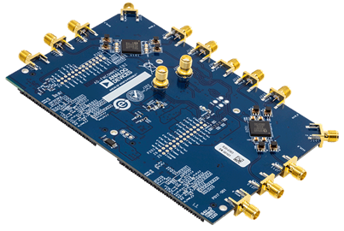

Fig 1. Analog Devices FMComms5 AD9361 RF Transceiver Evaluation Board

The next major component in the system architecture is the Xilinx Zynq-7000 SoC 702 board, which acts as the central controller for data acquisition and communication between the FMComms5 and the MATLAB processing environment. The Zynq’s hybrid design, combining a dual-core ARM Cortex-A9 processor with an FPGA fabric, enables high-speed digital interfacing with the FMComms5 while running Linux-based software for system control. Once the IQ samples are captured and buffered on the FPGA side, the Zynq transmits the data to the host computer over Ethernet, where MATLAB performs covariance estimation and MUSIC processing. This division of responsibilities keeps time-critical data movement on the Zynq hardware while delegating computationally intensive algorithms to the host system. The Zynq also maintains stable synchronization between the SDR front end and MATLAB’s processing loop, ensuring proper timing alignment across the snapshots used in the MUSIC algorithm. Overall, it serves as an essential bridge between the RF acquisition hardware and the high-level signal processing environment, enabling real-time operation of the complete localization system.

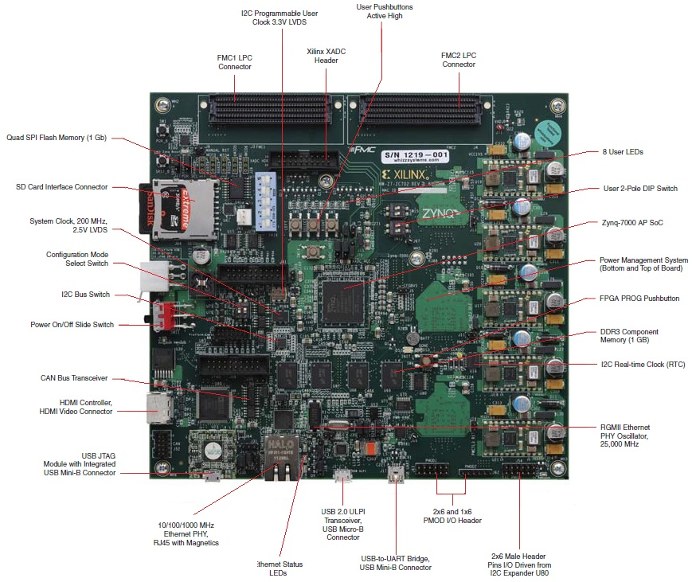

Fig 2. Xilinx Zynq-7000 SoC 702 Board

The antenna arrays consist of eight total omnidirectional 2.4 GHz vertically-polarized antennas arranged into two independent subarrays: a Uniform Circular Array (UCA) for azimuth estimation and a Vertical Uniform Linear Array (ULA) for elevation estimation. Their omnidirectional gain pattern ensures consistent signal reception regardless of UAV bearing, while λ/2 element spacing (≈6.25 cm) minimizes spatial aliasing and maximizes MUSIC resolution. The antennas mount to 3D-printed fixtures that maintain precise geometry and ensure repeatable phase behavior between elements.

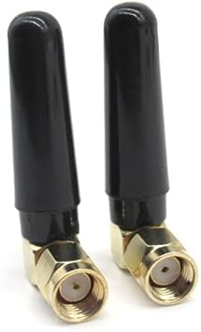

Fig 3. 2.4GHz Omni-Directional Mini-Antenna

The next piece of equipment in the system architecture is the TF02-Pro Single-Point Ranging LiDAR, an IP65-rated 40-meter laser distance sensor designed for high-accuracy, long-range measurement. The TF02-Pro is capable of producing stable time-of-flight distance readings with centimeter-level resolution, even in outdoor environments with variable lighting and atmospheric conditions. In this project, the LiDAR is mounted on a servo-driven Pan & Tilt mechanism and is controlled by the Arduino Mega, which receives azimuth and elevation estimates from MATLAB and positions the sensor toward the predicted UAV direction. Once oriented, the TF02-Pro provides precise range measurements that, when combined with the MUSIC-based angle estimates, allow the system to compute full three-dimensional localization of the target. The TF02-Pro was selected for its robustness, compact size, and ability to operate reliably in challenging environments, including those with dust, light rain, or partial obstruction, thanks to its IP65 enclosure. Its high measurement rate and narrow field-of-view make it well-suited for targeted ranging once the direction-of-arrival is determined.

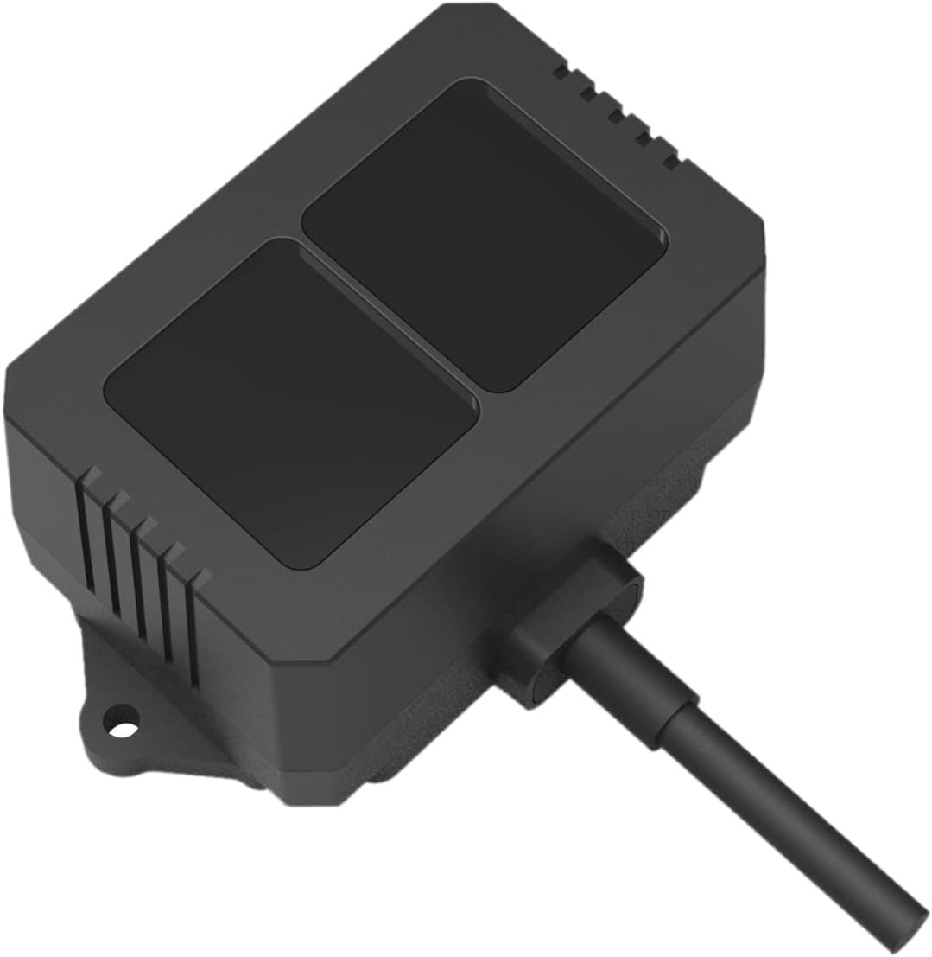

Fig 4. TF02-Pro Single-Point Ranging Lidar IP65 40m Laser Distance Sensor

The next component/system used in this project is the USRP-2901/Raspberry Pi 5 transmitting testbed. This platform represents the drone in the final system and provides a controllable 2.4 GHz transmission source for the antenna array. The USRP-2901 is a dual-channel software-defined radio (SDR) capable of wideband operation, allowing precise control over carrier frequency, modulation, and transmit power. It is interfaced with a Raspberry Pi 5, which functions as the onboard processor responsible for generating the baseband signal, configuring SDR parameters, and executing real-time transmission scripts. Together, the USRP and Raspberry Pi form a flexible and portable testbed that emulates expected drone communication behavior while enabling controlled laboratory testing of beamforming, signal detection, and direction-finding performance. This design gives an easily versatile system that can be moved and test multiple different angles of azimuth and elevation around the antenna array at different distances.

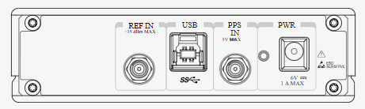
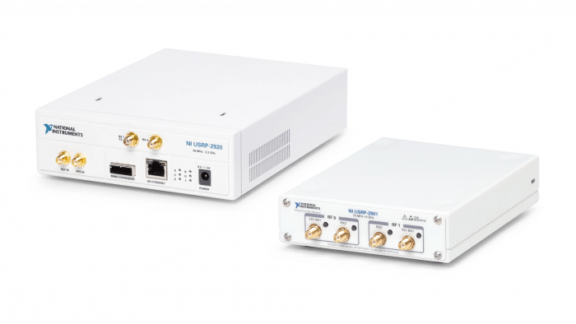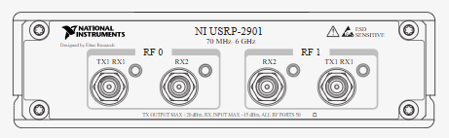

Fig 5. USRP-2901 Transceiver

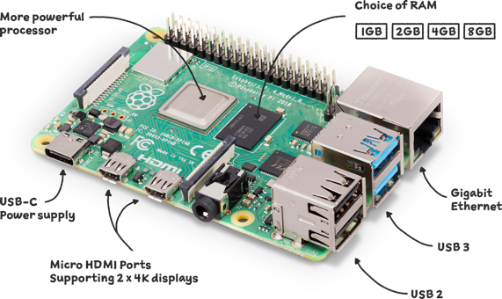

Fig 6. Raspberry Pi 5 component breakdown

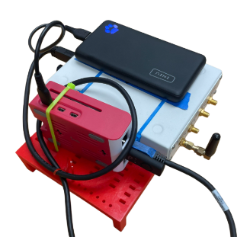

Fig 7. USRP/Raspberry Pi 2.4GHz Transmitter Testbed
  - System Overview
This section provides a high-level overview of the complete hardware architecture used for RF signal acquisition and localization. The system consists of three primary subsystems: the antenna arrays used to capture the incoming RF signal, the RF receiver and digital processing hardware responsible for signal sampling and DoA estimation, and the mechanical LiDAR range measurement system used to determine the distance to the emitter. Together these components form a hybrid localization platform capable of estimating the azimuth, elevation, and range of an RF source.
The antenna array used in the final system evolved through several generations of mechanical designs as the project progressed. The earliest design was developed around the Vert 2450 antennas, which were relatively large and flexible, making them difficult to mount in a rigid and repeatable configuration. As a result, the team transitioned to smaller omni-directional Wi-Fi antennas that provided similar operating characteristics while allowing for a more compact and mechanically stable array structure. With the change in antenna type, the mechanical structure of the array was redesigned multiple times to improve stability, alignment accuracy, and ease of integration with the rest of the hardware platform. Early generations focused primarily on supporting the antenna elements, while later iterations incorporated improved mounting brackets, structural supports, and integration points for the RF receiver and range sensing systems. The final design provides a rigid platform capable of maintaining consistent antenna spacing and orientation, which is critical for accurate phase-based direction-of-arrival estimation. This iterative design process ultimately resulted in the current antenna platform shown in Fig. X, which supports the antenna arrays, RF hardware, and mechanical range system within a single integrated structure.
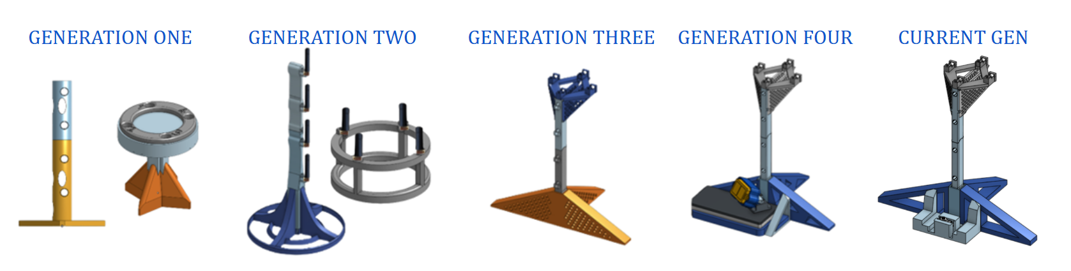

Fig 8. Antenna Array Generation
The figure illustrates the complete hardware architecture of the RF localization platform and how each subsystem interacts to estimate the azimuth, elevation, and range of a transmitted signal. A controllable 2.4 GHz RF source is generated using a USRP-2901 transceiver connected to a Raspberry Pi, which acts as a portable transmitter used during system testing. The transmitted signal is received by the multi-element antenna array composed of a uniform circular array (UCA) and a vertical uniform linear array (ULA). Signals from each antenna element are routed through RF coaxial cables into the Analog Devices FMComms5 receiver platform, where synchronized multi-channel sampling is performed using the dual AD9361 transceivers. The digitized IQ samples are transferred through the Zynq processing board to a host computer running MATLAB, where covariance estimation and subspace-based direction-of-arrival algorithms are executed to determine the azimuth and elevation of the emitter. These angle estimates are then transmitted to an Arduino-based pan-tilt servo controller, which positions a LiDAR sensor toward the estimated direction of the source. The LiDAR system provides an independent range measurement, and when combined with the RF-derived angular estimates, the system can determine the full localization of the transmitter.
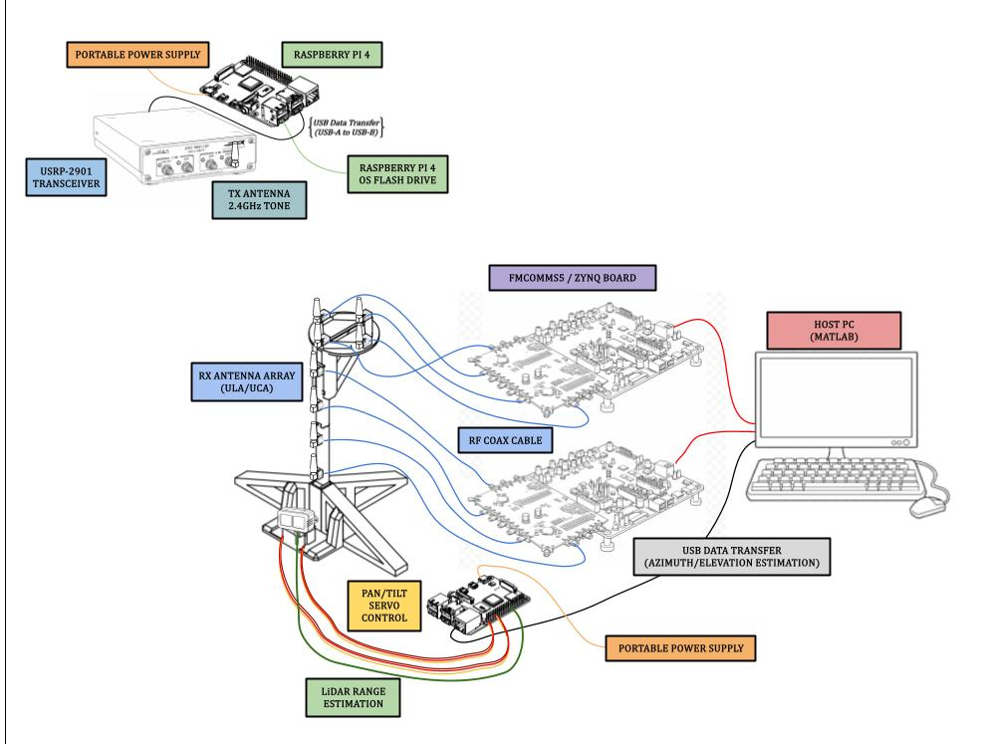
Fig 9. Live Demo Complete Implementation Visualization

For further information regarding system connections and implementation details, complete electrical CAD drawings and the bill of materials are provided at the end of the appendices for reference.

